

National University of Sciences & Technology

School of Electrical Engineering and Computer Science

Department of Computing

**CS-220: DATABASE SYSTEMS (3+1): BSCS-8AB Fall 2019**

**Project Report**

**SUBMITTED TO: Dr. SHAMS UD DIN QAZI**

**SUBMITTED BY:**

1. **SHARIQ BIN RASHID (242431)**
2. **FAIZAN QAZI (263118)**
3. **DANIAL AHMED (249912)**
4. **ANAS IMRAN CHEEMA()**

**Class (Section): BSCS-8B**

**Date of Submission: 11-12-19**

**HELPYAR**

# **Database Management System:**

Er:

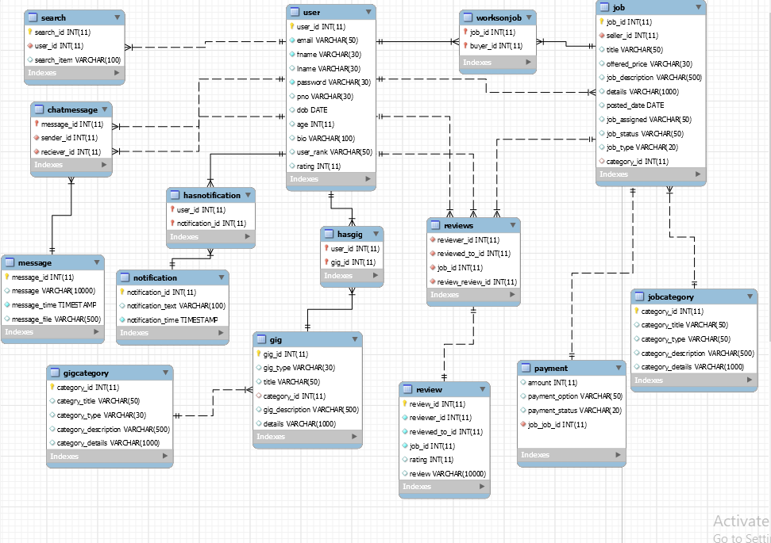

# APP FRONT END SCREENSHOTS:

